

University OF Layyah

(Department OF Information & Tecnology)

Manual Test Cases

Submitted To:

Sir Faisal Hafeez

Subject:

**Software Testing & Quality Assurance**

|  |  |
| --- | --- |
| Test Case ID | TC_WIKI_01 |
| Test Case Title | Verify that Wikipedia homepage loads successfully |
| Pre-Conditions | User has a stable internet connection and a supported web browser installed |
| Test Steps | 1. Open a web browser  2. Enter https://www.wikipedia.org in the  address bar  3. Press Enter |
| Test Data | URL: https://www.wikipedia.org |
| Expected Result | Wikipedia homepage should load successfully and display the Wikipedia logo, search box, and language selection options |
| Actual Result | Wikipedia homepage loaded successfully; all elements (logo, search box, languages) visible |
| Status | Pass |
| Remarks | Homepage loaded correctly; ready for further testing |

**Screenshot:**

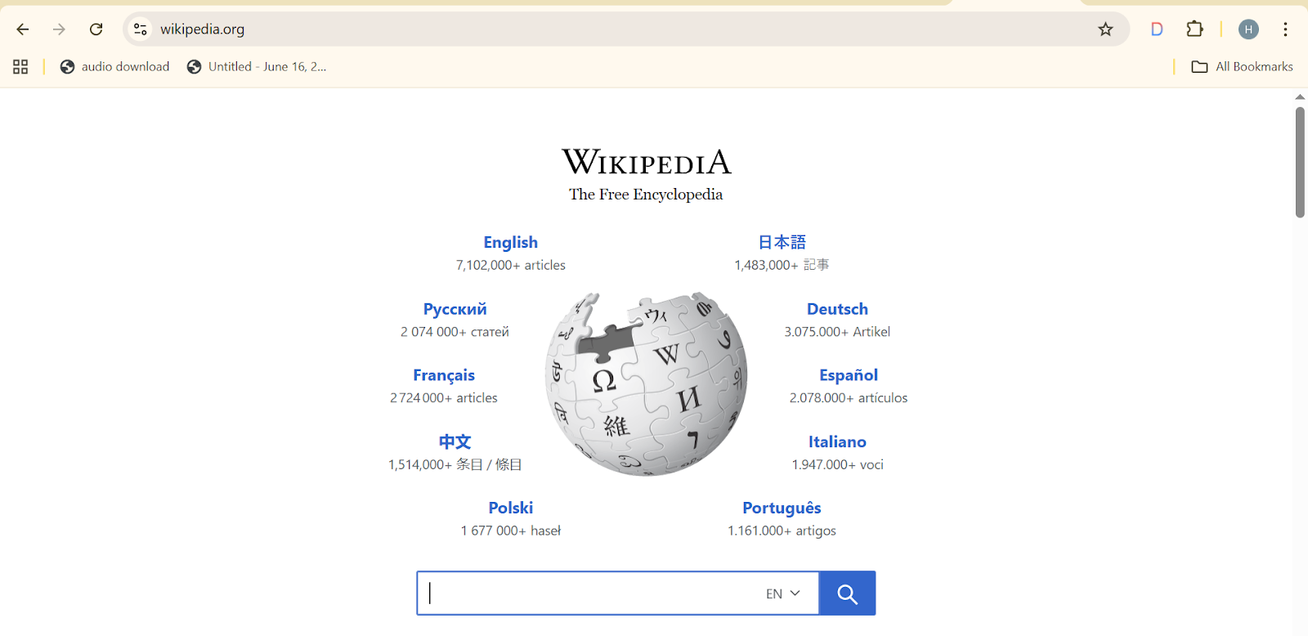

|  |  |
| --- | --- |
| Test Case ID | TC_WIKI_02 |
| Test Case Title | Verify that user can change Wikipedia homepage language |
| Pre-Conditions | Wikipedia homepage is loaded |
| Test Steps | 1. Locate the language selection section on the homepage  2. Click on a different language (e.g., Español)  3. Observe page reload |
| Test Data | Selected Language: Español |
| Expected Result | Wikipedia homepage reloads in the selected language; all page elements (logo, search box, links) appear in the chosen language |
| Actual Result | Wikipedia homepage reloaded in Español successfully; all elements displayed correctly |
| Status | Pass |
| Remarks | Language switching works as expected; no layout issues observed |

**Screenshot:**

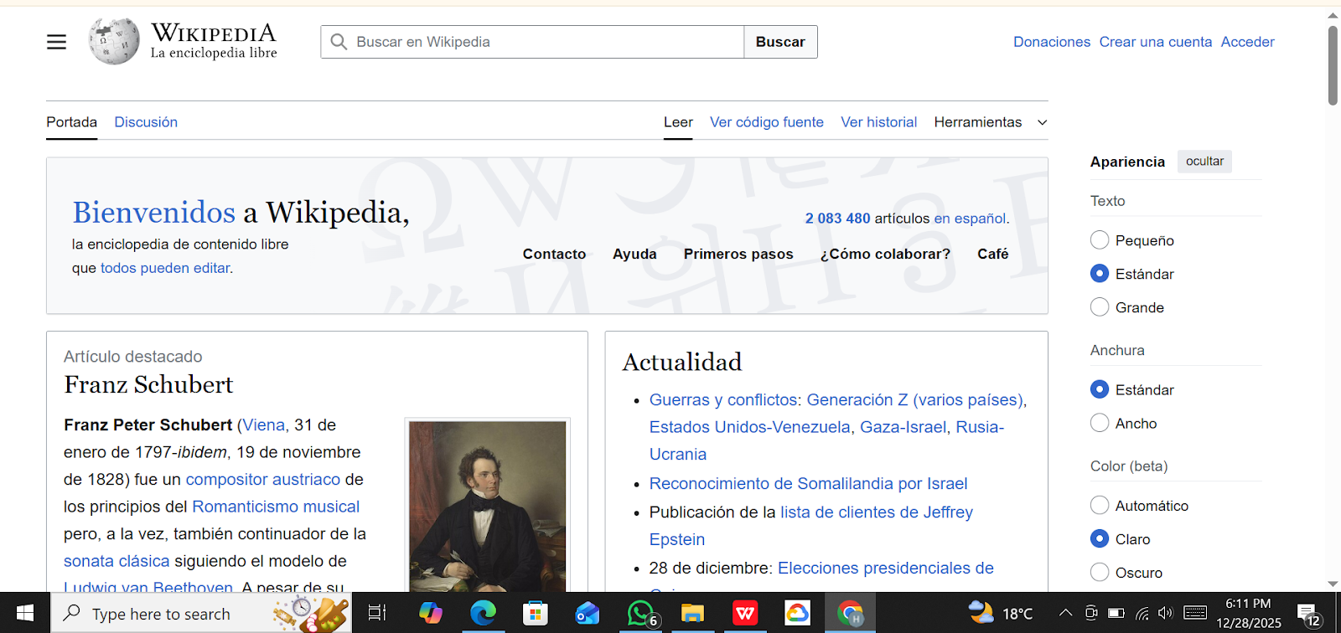

|  |  |
| --- | --- |
| Test Case ID | TC_WIKI_03 |
| Test Case Title | Verify that user can search Wikipedia articles using a valid keyword |
| Pre-Conditions | Wikipedia homepage is loaded |
| Test Steps | 1. Click on the search bar on the Wikipedia homepage  2. Enter a valid keyword (e.g., "Software Testing")  3. Click the search button or press Enter  4. Observe the search results |
| Test Data | Keyword: Software Testing |
| Expected Result | Search results should display relevant articles; clicking a result should open the correct article page |
| Actual Result | Search results for "Software Testing" displayed correctly; article page opened successfully |
| Status | Pass |
| Remarks | Search functionality working as expected; results relevant |

**Screenshot:**

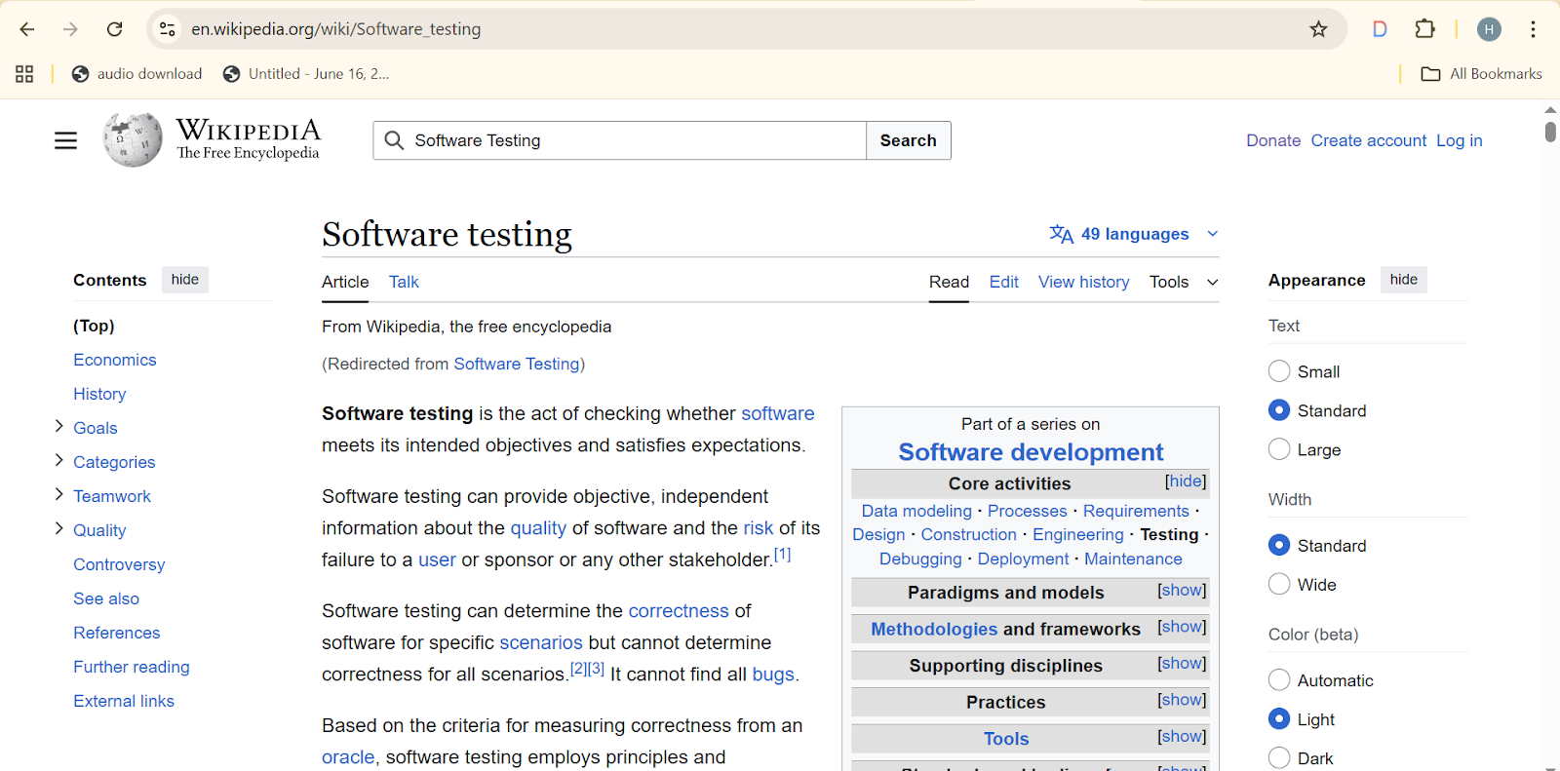

|  |  |
| --- | --- |
| Test Case ID | TC_WIKI_04 |
| Test Case Title | Verify Wikipedia search behavior using an invalid or random keyword |
| Pre-Conditions | Wikipedia homepage is loaded |
| Test Steps | 1. Click on the search bar on the Wikipedia homepage  2. Enter an invalid or random keyword (e.g., "@@@###")  3. Click the search button or press Enter  4. Observe the search results or messages displayed |
| Test Data | Keyword: @@@### |
| Expected Result | System should display “No results found” message or suggest related articles; page should not crash |
| Actual Result | “No results found” message displayed correctly; no errors observed |
| Status | Pass |
| Remarks | Negative test case passed; system handled invalid input gracefully |

**Screenshot:**

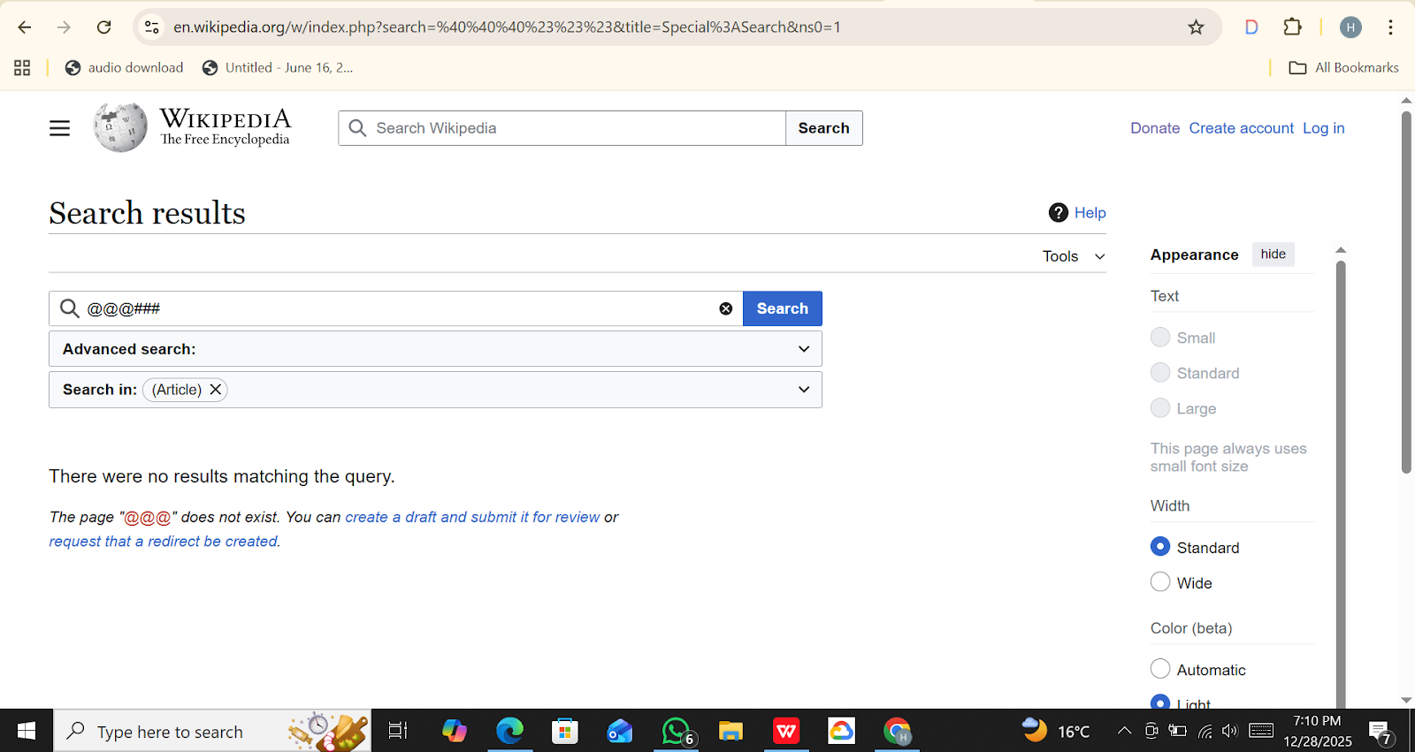

|  |  |
| --- | --- |
| Test Case ID | TC_WIKI_05 |
| Test Case Title | Verify that a Wikipedia article page loads correctly when a search result is clicked |
| Pre-Conditions | Wikipedia homepage is loaded and a search has been performed with a valid keyword |
| Test Steps | 1. Perform a search using a valid keyword (e.g., "Software Testing")  2. Click on one of the search result links  3. Observe the article page loading  4. Verify headings, content, and images on the article page |
| Test Data | Search Keyword: Software Testing |
| Expected Result | Article page should load successfully with correct headings, content, images, and internal links |
| Actual Result | Article page for "Software Testing" loaded correctly; all content, headings, and images displayed as expected |
| Status | Pass |
| Remarks | Article page navigation is working properly; no layout or content issues observed |

**Screenshot:**

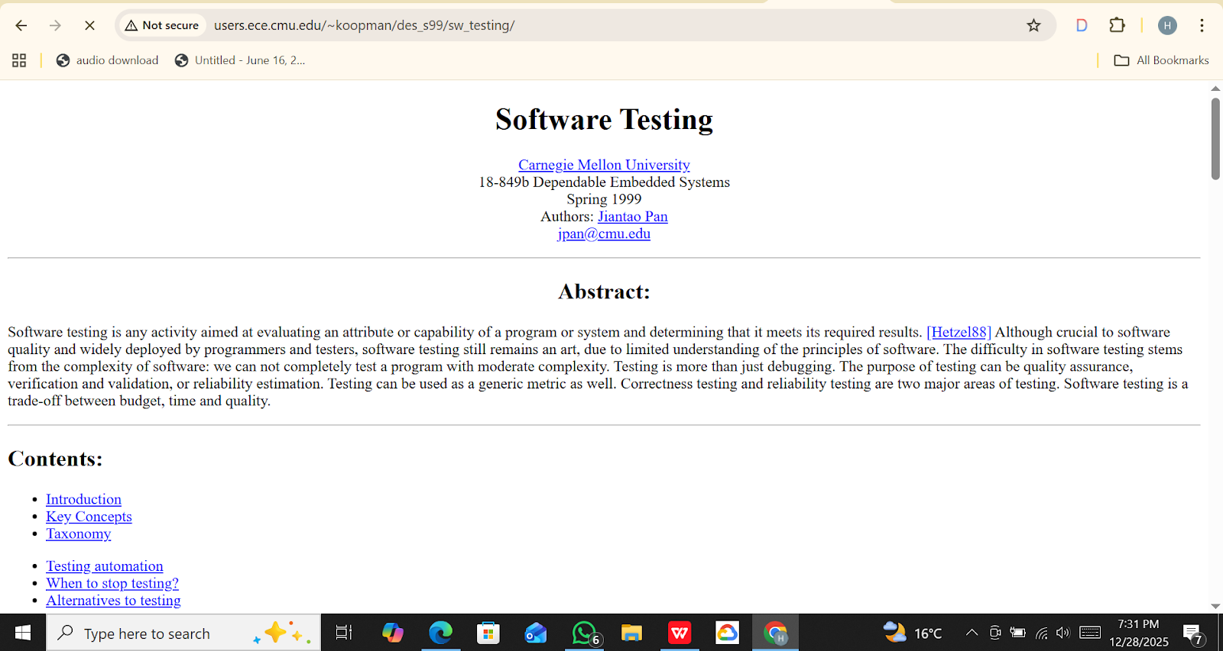

|  |  |
| --- | --- |
| Test Case ID | TC_WIKI_06 |
| Test Case Title | Verify that internal links within a Wikipedia article navigate correctly |
| Pre-Conditions | A Wikipedia article page is loaded |
| Test Steps | 1. Open any Wikipedia article (e.g., "Software Testing")  2. Identify an internal link within the article content  3. Click the internal link  4. Observe if the linked article loads correctly |
| Test Data | Internal link: "Software Development" (within "Software Testing" article) |
| Expected Result | The linked article should load successfully; content and headings should be displayed correctly |
| Actual Result | Internal link clicked successfully; "Software Development" article loaded with correct content and headings |
| Status | Pass |
| Remarks | Internal navigation within articles is working as expected |

**Screenshot:**

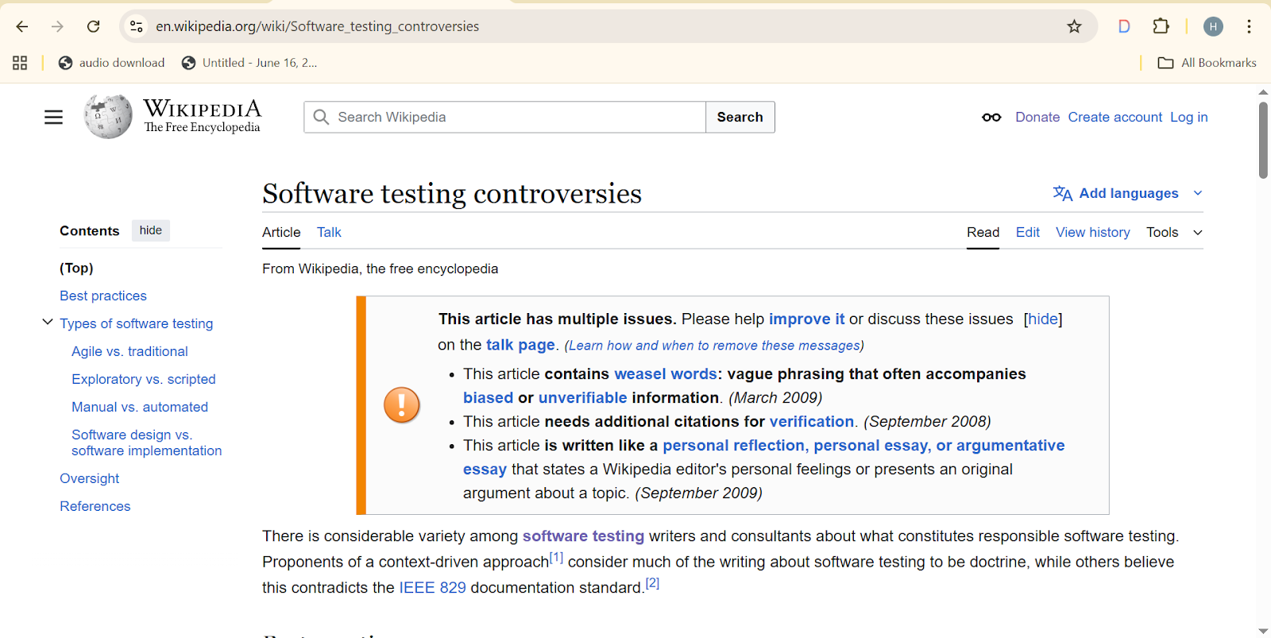

|  |  |
| --- | --- |
| Test Case ID | TC_WIKI_07 |
| Test Case Title | Verify that Wikipedia homepage and article pages display UI elements correctly across different screen sizes |
| Pre-Conditions | Wikipedia homepage or any article page is loaded |
| Test Steps | 1. Open Wikipedia homepage or any article page  2. Observe layout on desktop screen  3. Resize browser window to tablet and mobile screen      widths  4. Check visibility and alignment of logo, search bar,       language selector, headings, and content  5. Scroll through page to verify content rendering |
| Test Data | Screen widths: Desktop (1920px), Tablet (768px), Mobile (375px) |
| Expected Result | UI elements (logo, search bar, language selector, headings, content) should adjust and remain visible correctly on all screen sizes; no overlapping or broken layout |
| Actual Result | UI elements displayed correctly on desktop, tablet, and mobile resolutions; layout responsive and readable |
| Status | Pass |
| Remarks | Responsive design works as expected; no visual issues observed |

**Screenshot:**

**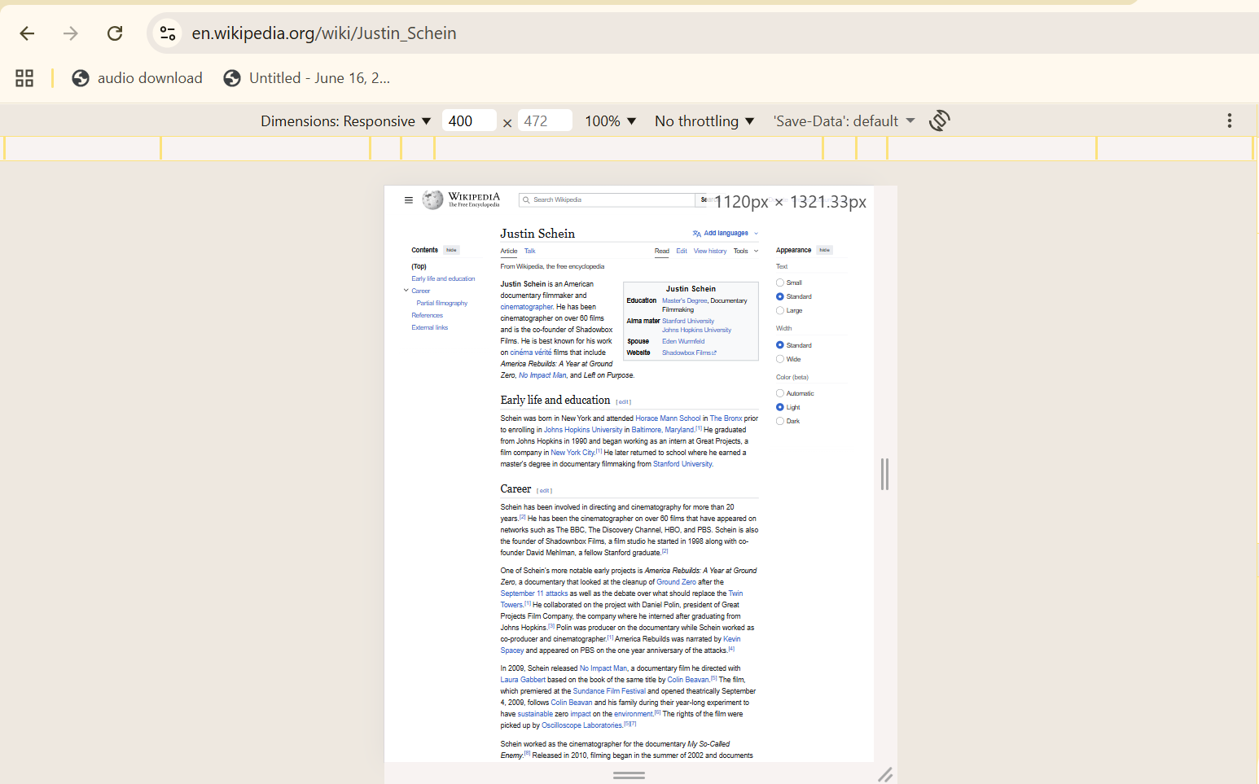      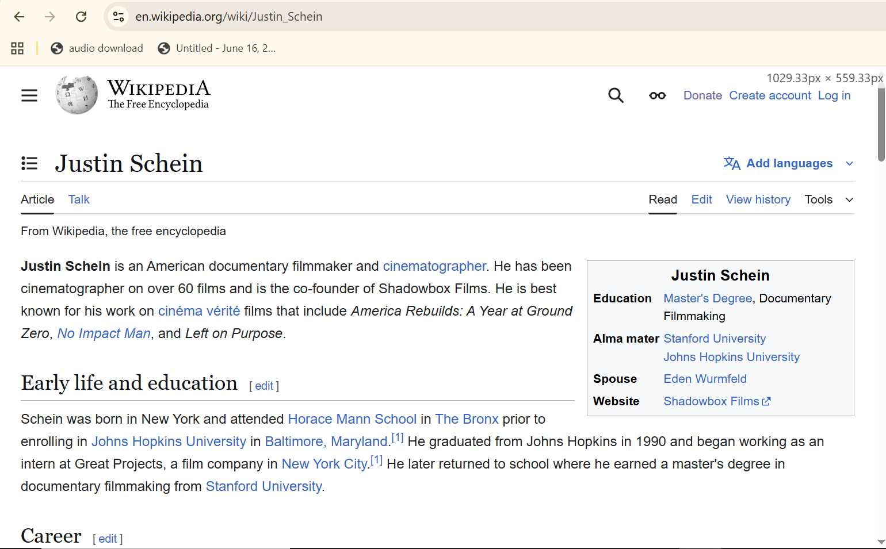**

|  |  |
| --- | --- |
| Test Case ID | TC_WIKI_08 |
| Test Case Title | Verify Wikipedia API returns correct search results for a valid keyword |
| Pre-Conditions | Internet connection available; API endpoint accessible: https://en.wikipedia.org/w/api.php |
| Test Steps | 1. Open Postman or any API testing tool  2. Set GET request to: https://en.wikipedia.org/w/api.php?action=query&list=search&srsearch=Software%20Testing&format=json    3. Send the request  4. Observe the JSON response  5. Verify that search results include relevant articles for       "Software Testing" |
| Test Data | Keyword: Software Testing  API Endpoint: https://en.wikipedia.org/w/api.php?action=query&list=search&srsearch=Software%20Testing&format=json |
| Expected Result | API should return JSON containing search results with titles and snippets relevant to "Software Testing" |
| Actual Result | API returned JSON with multiple articles; titles and snippets relevant to "Software Testing" |
| Status | Pass |
| Remarks | Wikipedia search API responded correctly; results verified in JSON response |

**Screenshot:**

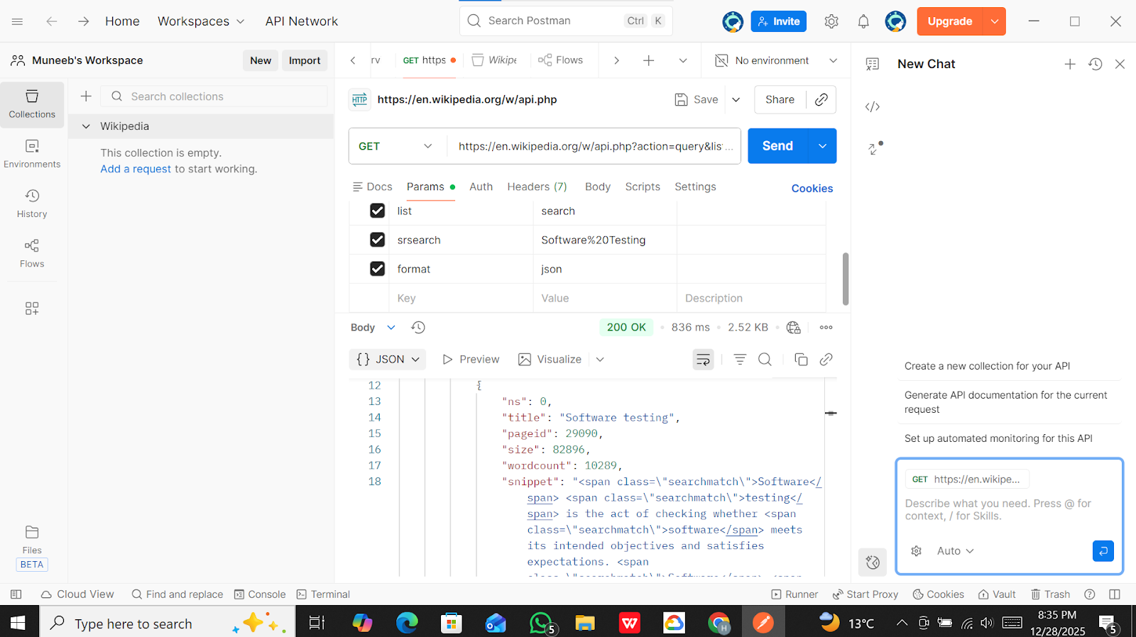

|  |  |
| --- | --- |
| Test Case ID | TC_WIKI_9 |
| Test Case Title | Verify that external links on Wikipedia open correctly |
| Pre-Conditions | Wikipedia homepage is loaded |
| Test Steps | 1. Open Wikipedia homepage  2. Scroll to the bottom (footer section)  3. Identify any external link (e.g., Wikimedia Foundation,      Privacy Policy)  4. Click on the external link  5. Observe browser behavior |
| Test Data | External links: Wikimedia Foundation, Privacy Policy  Browser: Chrome |
| Expected Result | External link opens successfully in a new browser tab without any error |
| Actual Result | External link opened correctly in a new tab and content loaded successfully |
| Status | Pass |
| Remarks | External links are functional and redirect users to correct external pages |

**Screenshot:**

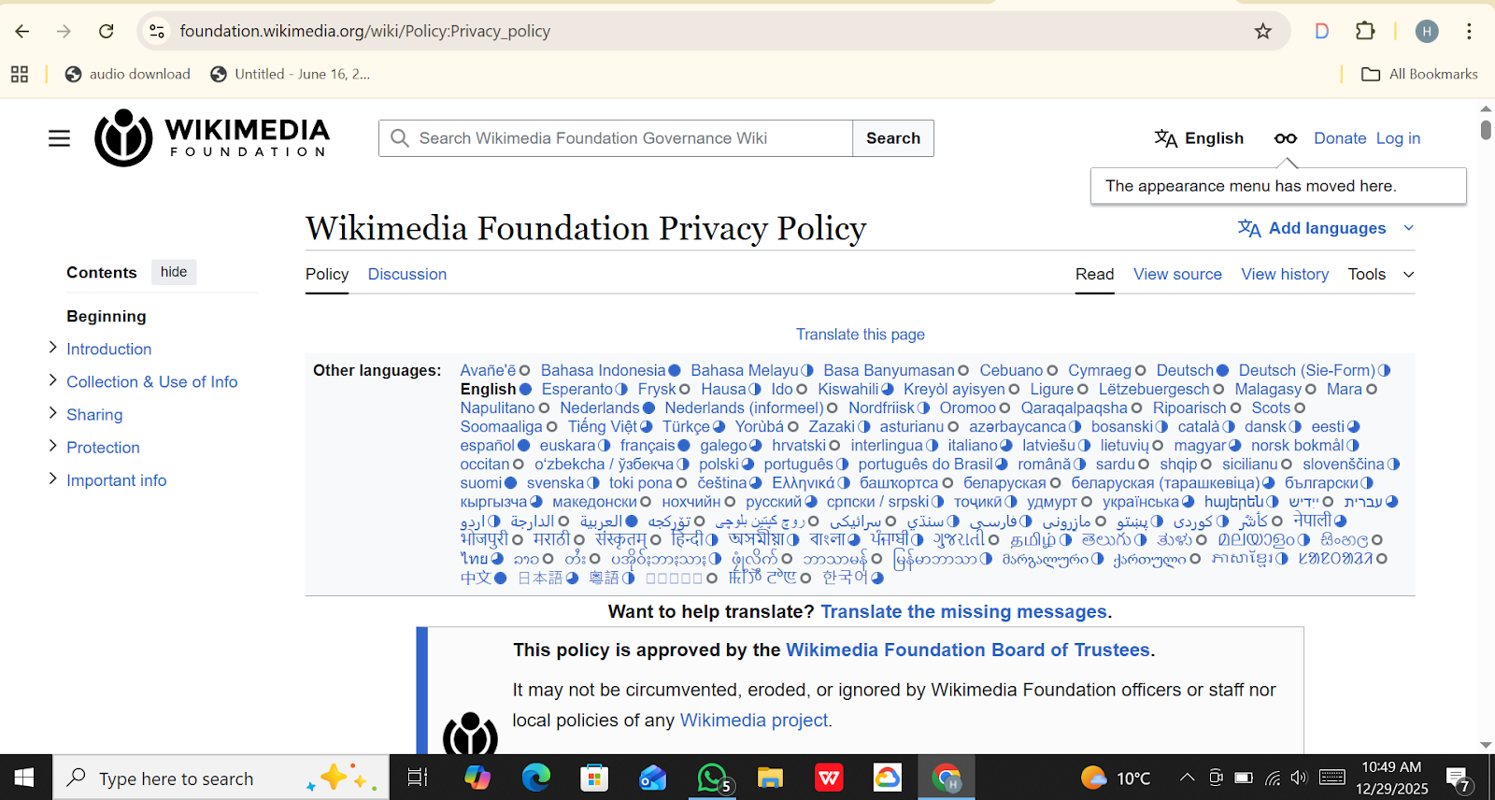

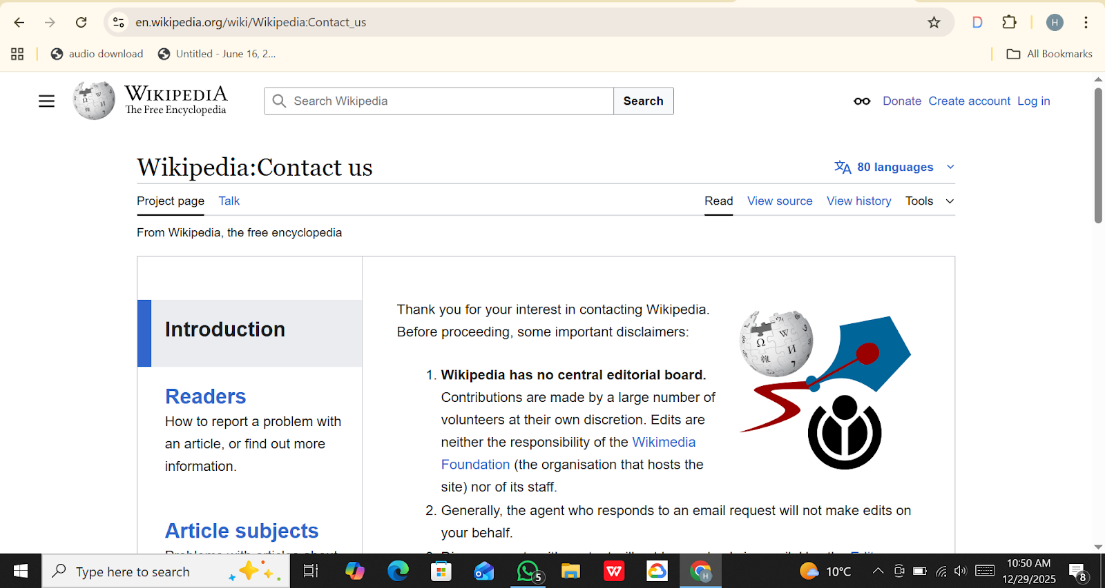

|  |  |
| --- | --- |
| Test Case ID | TC_WIKI_10 |
| Test Case Title | Verify that external reference links on a Wikipedia article open correctly |
| Pre-Conditions | Wikipedia homepage is accessible |
| Test Steps | 1. Open Wikipedia homepage  2. Search for an article (e.g., Software testing)  3. Open the article page  4. Scroll down to the References section  5. Click on any external reference link  6. Observe the behavior of the link |
| Test Data | Article Name: Software testing  Browser: Chrome |
| Expected Result | External reference link should open the correct source page in a new browser tab without errors |
| Actual Result | External reference link opened in the same browser tab instead of a new tab; user navigated back to the article using browser back button |
| Status | Fail |
| Remarks | External reference links do not open in a new tab as expected; this may impact user navigation experience |

**Screenshot:**

**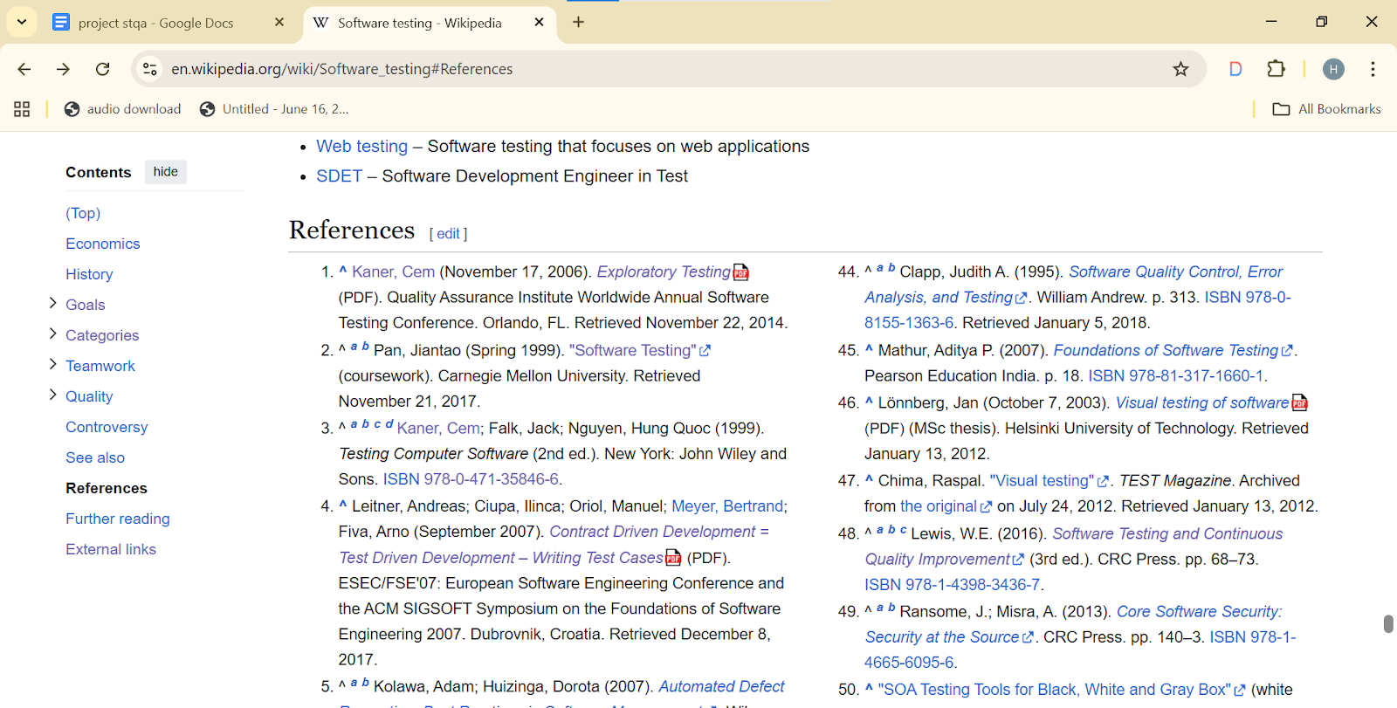  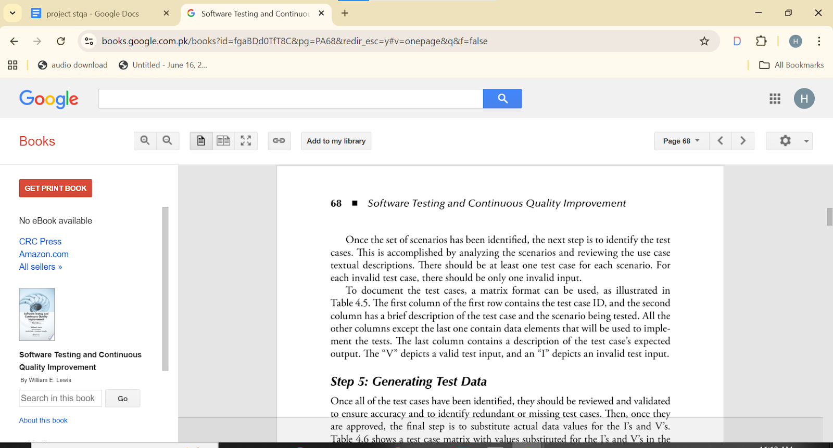**

|  |  |
| --- | --- |
| Test Case ID | TC_WIKI_11 |
| Test Case Title | Verify that Table of Contents navigate to correct sections within a Wikipedia article |
| Pre-Conditions | Wikipedia website with Software testing article is accessible |
| Test Steps | 1. Open the article page  2. Locate the Table of Contents section  3. Click on any section link (e.g., History, Types,       Techniques)  4. Observe page navigation |
| Test Data | Article Name: Software testing  Browser: Chrome |
| Expected Result | Page should smoothly navigate to the selected section within the same article |
| Actual Result | Page navigated correctly to the selected section; section heading displayed at top |
| Status | Pass |
| Remarks | Table of Contents navigation is working correctly; internal anchor links function as expected |

**Screenshot:**

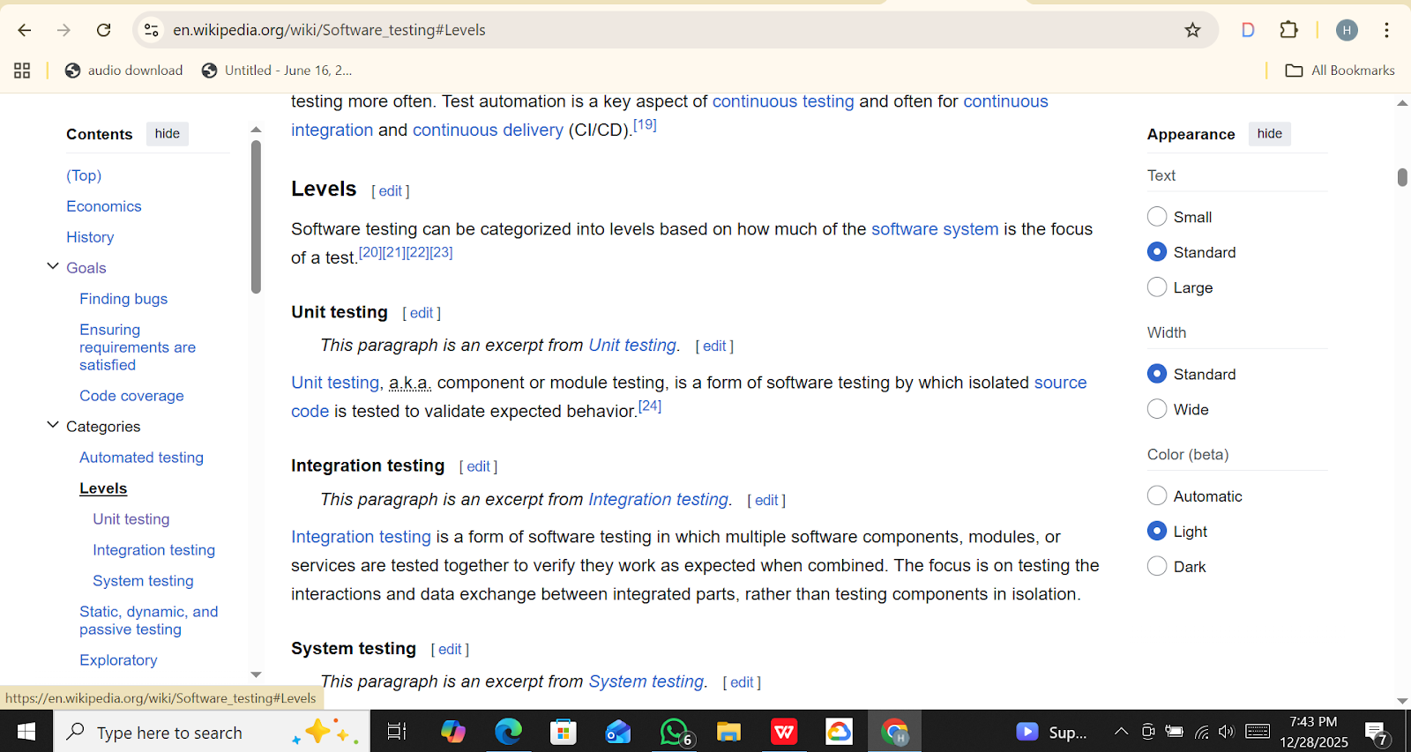

|  |  |
| --- | --- |
| Test Case ID | TC_WIKI_12 |
| Test Case Title | Verify that Wikipedia search auto-suggestions appear correctly while typing |
| Pre-Conditions | Wikipedia homepage is accessible |
| Test Steps | 1. Open Wikipedia homepage  2. Click on the search input field  3. Start typing a keyword (e.g., soft)  4. Observe the search suggestions dropdown  5. Click on any suggested result |
| Test Data | Search Keyword: soft  Browser: Chrome |
| Expected Result | Relevant search suggestions should appear in a dropdown and clicking a suggestion should open the related article |
| Actual Result | Search suggestions appeared correctly and selected suggestion opened the appropriate article page |
| Status | Pass |
| Remarks | Search auto-suggestion feature works as expected and improves search usability |

**Screenshot:**

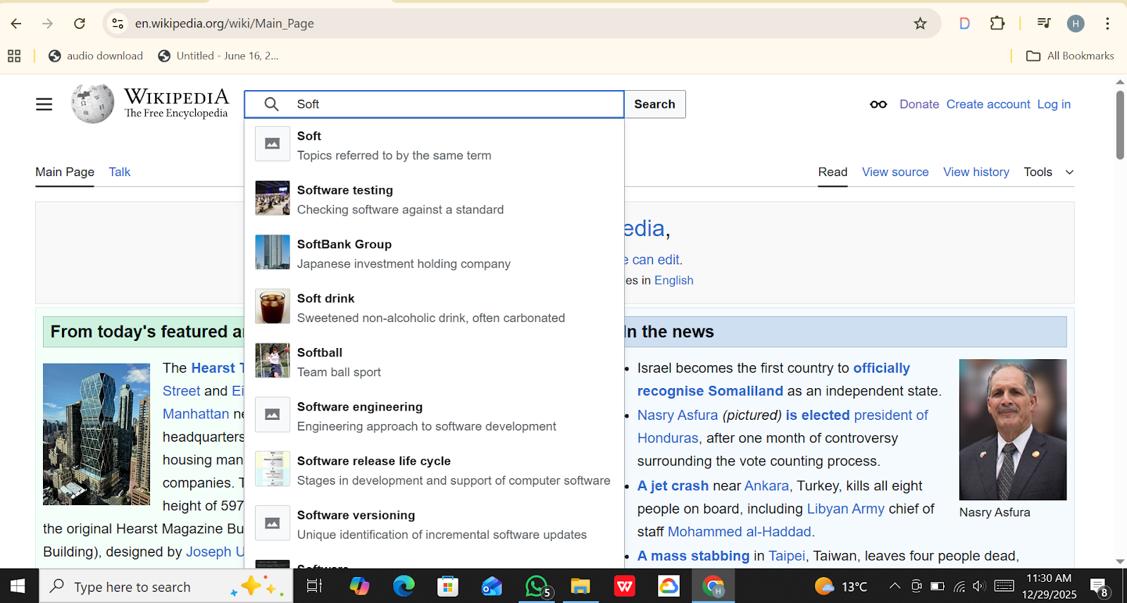

|  |  |
| --- | --- |
| Test Case ID | TC_WIKI_13 |
| Test Case Title | Verify that article edit history page opens correctly |
| Pre-Conditions | Wikipedia website is accessible |
| Test Steps | 1. Open Wikipedia homepage  2. Search for an article (e.g., Software testing)  3. Open the article page  4. Click on the "View history" tab  5. Observe the history page |
| Test Data | Article Name: Software testing  Browser: Chrome |
| Expected Result | Edit history page should open and display list of edits with date, time, and contributor details |
| Actual Result | Edit history page opened successfully and displayed revision list with contributor information |
| Status | Pass |
| Remarks | Article edit history feature is accessible and functioning correctly |

**Screenshot:**

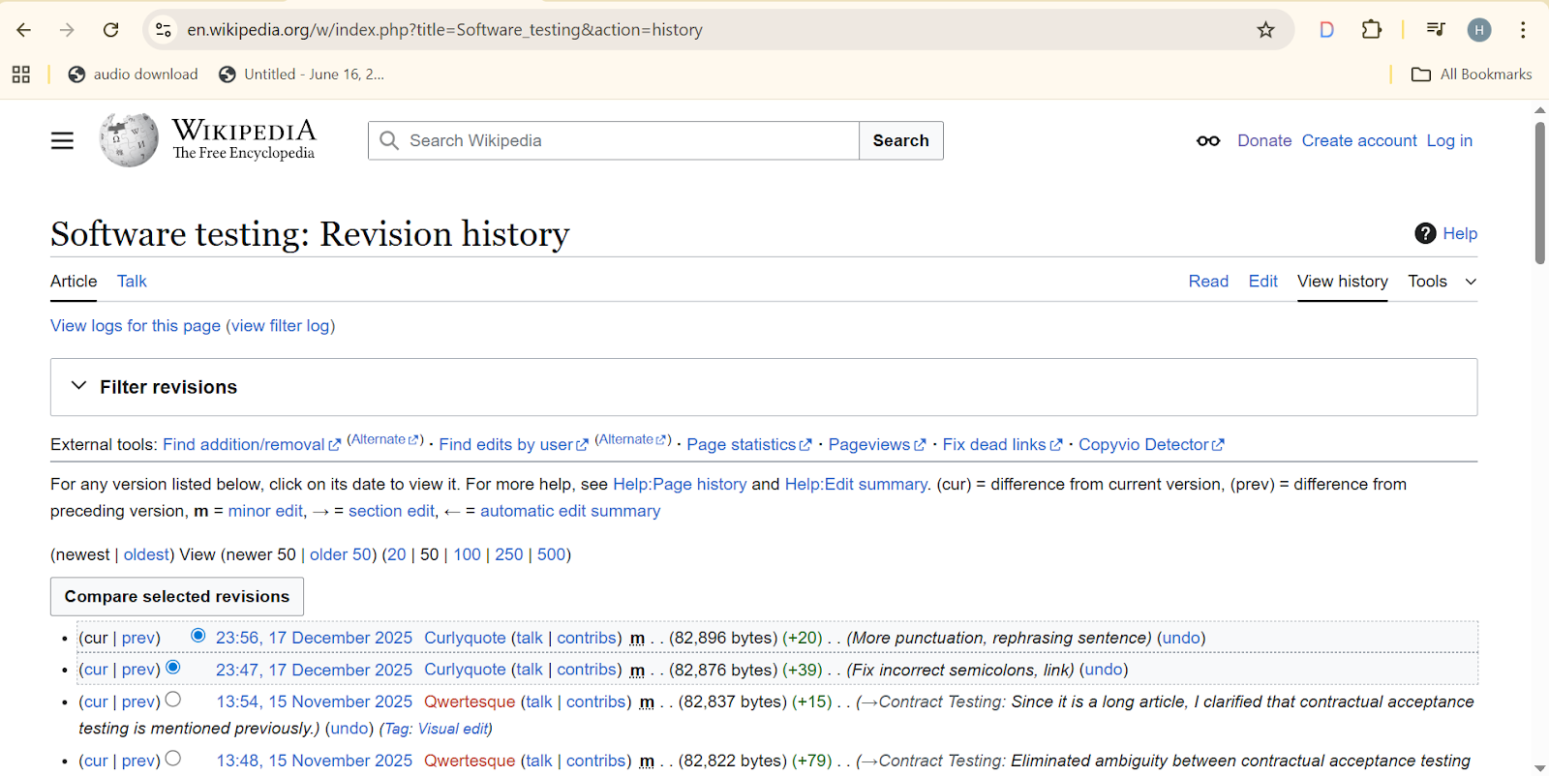

|  |  |
| --- | --- |
| Test Case ID | TC_WIKI_14 |
| Test Case Title | Verify that images and media files in a Wikipedia article load correctly |
| Pre-Conditions | Wikipedia homepage is accessible |
| Test Steps | 1. Open Wikipedia homepage  2. Search for an article (e.g., Software testing)  3. Open the article page  4. Scroll through the content and locate images / media      files  5. Verify that each image loads properly  6. Click on media to check enlargement / viewer      functionality |
| Test Data | Article Name: Software testing  Browser: Chrome |
| Expected Result | All images and media files should load correctly; clicking on media should open the media viewer or enlarged view |
| Actual Result | All images loaded successfully; media viewer opened correctly on clicking images |
| Status | Pass |
| Remarks | Images and media display correctly; no broken links or missing media found |

**Screenshot:**

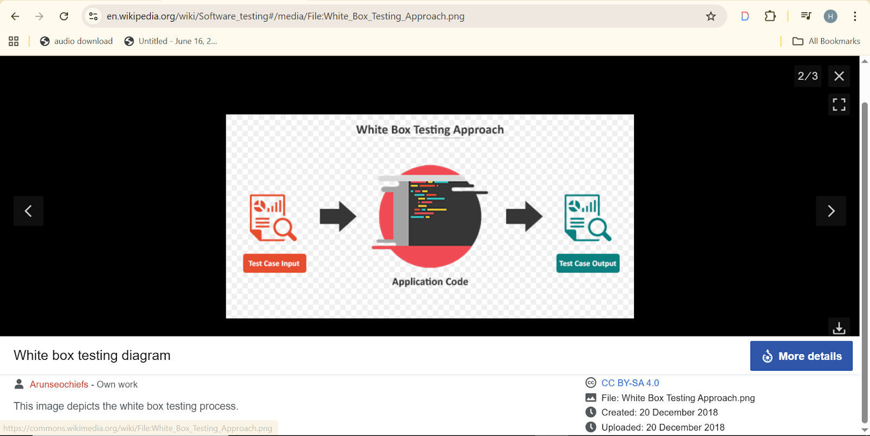

|  |  |
| --- | --- |
| Test Case ID | TC_WIKI_15 |
| Test Case Title | Verify mandatory fields validation on Wikipedia account creation form (Email left blank) |
| Pre-Conditions | Wikipedia homepage accessible   "Create account" page loaded |
| Test Steps | 1. Open Wikipedia homepage  2. Click on "Create account"  3. Fill Username, Password, Confirm Password fields  4. Leave Email field blank  5. Click "Create account"  6. Observe error message displayed for missing Email |
| Test Data | Username: (leave blank)  Password: Test@1234  Confirm Password: Test@1234  Email:  muneebhamza9191@gmail.com  Browser: Chrome |
| Expected Result | Error message displayed indicating that username is required |
| Actual Result | Error message appeared correctly: "username is a required field" |
| Status | Pass |
| Remarks | Mandatory field validation verified successfully; form prevented submission with blank username |

**Screenshot:**

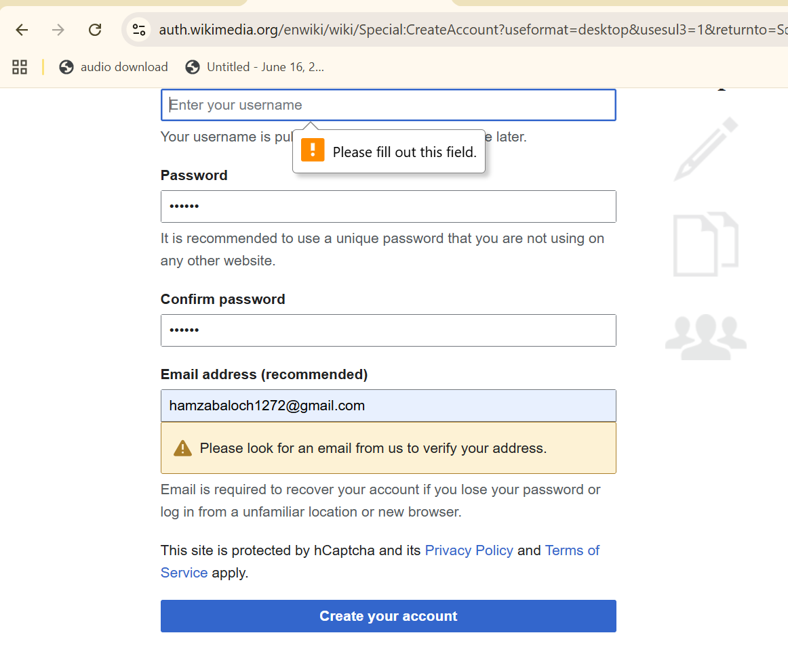

|  |  |
| --- | --- |
| Test Case ID | TC_WIKI_16 |
| Test Case Title | Verify mandatory fields validation on Wikipedia account creation form |
| Pre-Conditions | - Wikipedia homepage accessible  - "Create account" page loaded  - Internet connection active  - Browser open |
| Test Steps | 1. Open Wikipedia homepage  2. Click on "Create account"  3.Enter the  invalid email address or username invalid      formate  4. Click "Create account"  5. Observe error message displayed  6. Now, slightly change Password / Confirm Password (e.g., mismatch)  7. Click "Create account" again  8. Observe password mismatch error  9. Finally, enter all fields correctly and click "Create account"  10. Verify account creation success message or redirection |
| Test Data | Username: testuser123  Password: Test@1234  Confirm Password: Test@1234 (or mismatch for negative test)  Email: leave blank for first step, then enter valid email  Browser: Chrome |
| Expected Result | 1. If a mandatory field is blank → proper error message displayed  2. If Password ≠ Confirm Password → proper mismatch error displayed  3. When all fields are correct → account created successfully |
| Actual Result | 1. Invalid Syntax or Formate  2. Password mismatch error displayed correctly  3. Successful account creation after entering valid details |
| Status | Pass |
| Remarks | Mandatory field validation and password confirmation handling verified successfully; negative scenarios handled gracefully before positive scenario completion |

**Screenshot:**

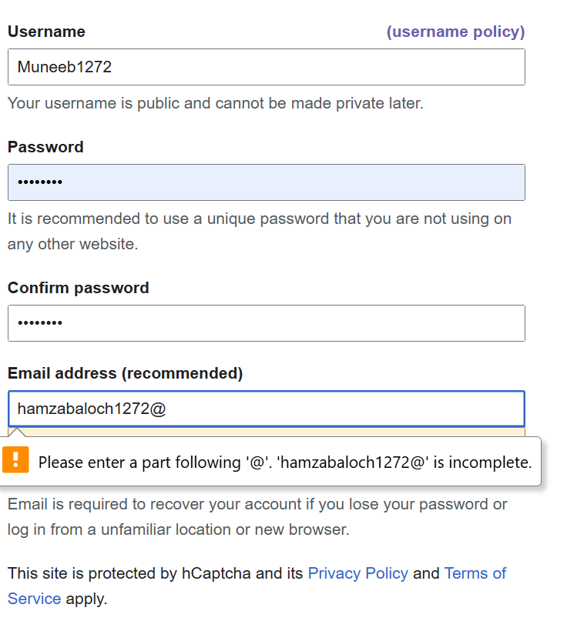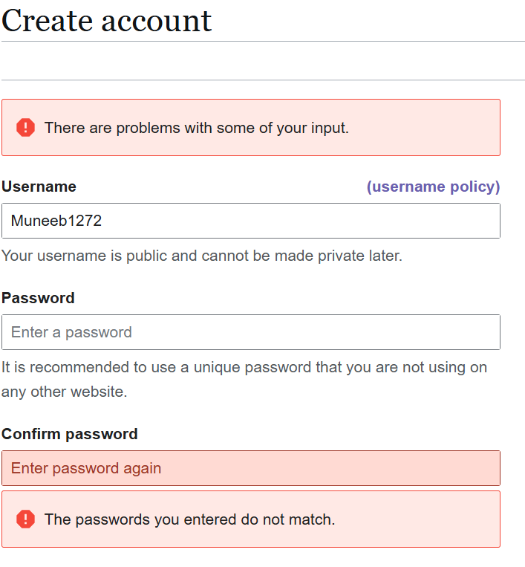

**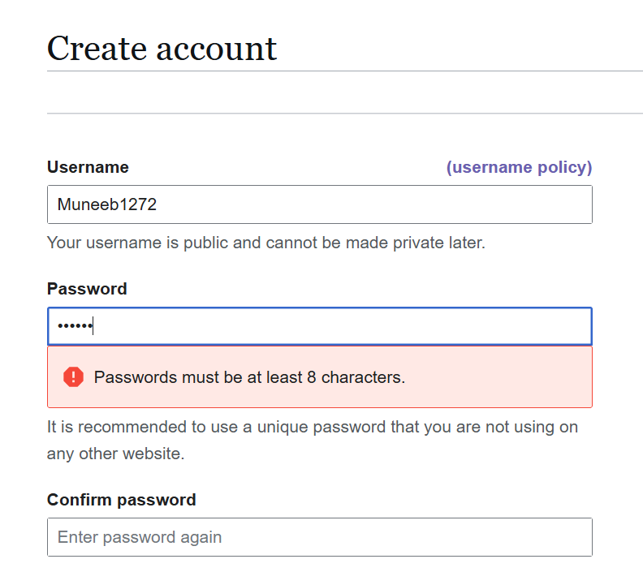        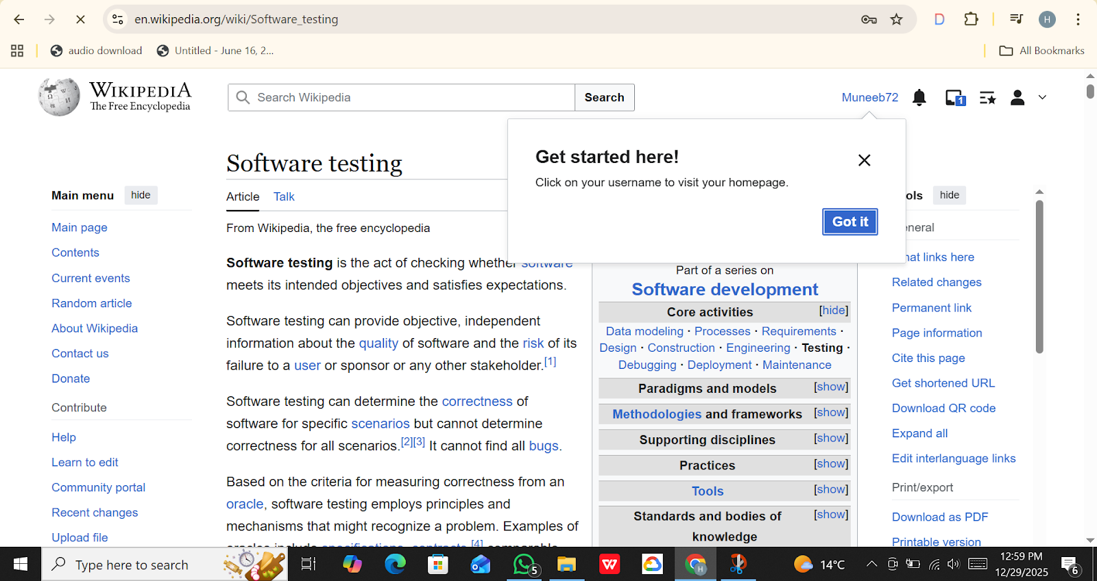**

|  |  |
| --- | --- |
| Test Case ID | TC_WIKI_17 |
| Test Case Title | Verify account creation fails with an already registered email |
| Pre-Conditions | Wikipedia homepage loaded  Internet connection active  Browser open |
| Test Steps | 1. Go to "Create Account" page  2. Enter a username  3. Enter a password & confirm password  4. Enter an email already registered (e.g., existing_user@gmail.com)  5. Click Create Account |
| Test Data | Username: testuser1  Password: Test@123  Confirm Password: Test@123  Email: existing_user@gmail.com |
| Expected Result | Error message: "Email already in use"  Account should not be created |
| Actual Result | Account creation proceeds; verification email message shown |
| Status | Fail |
| Remarks | Wikipedia allows duplicate emails in test scenario (potential bug) |

**Screenshot:**

**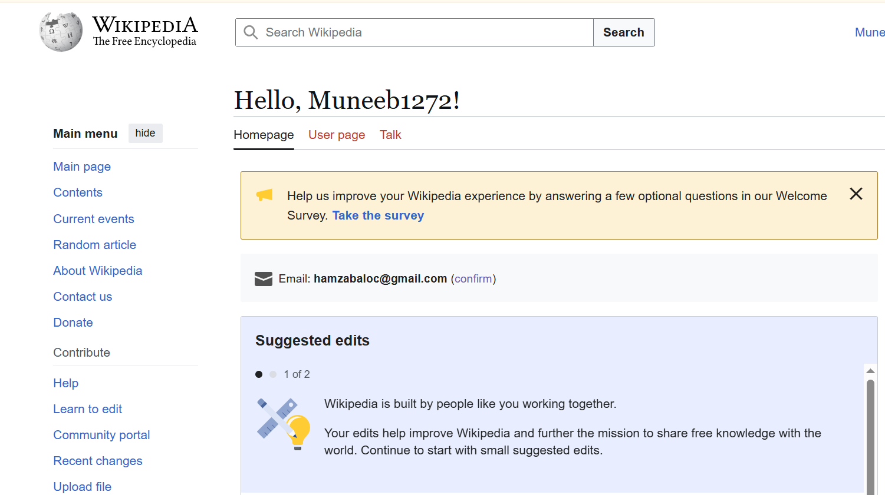      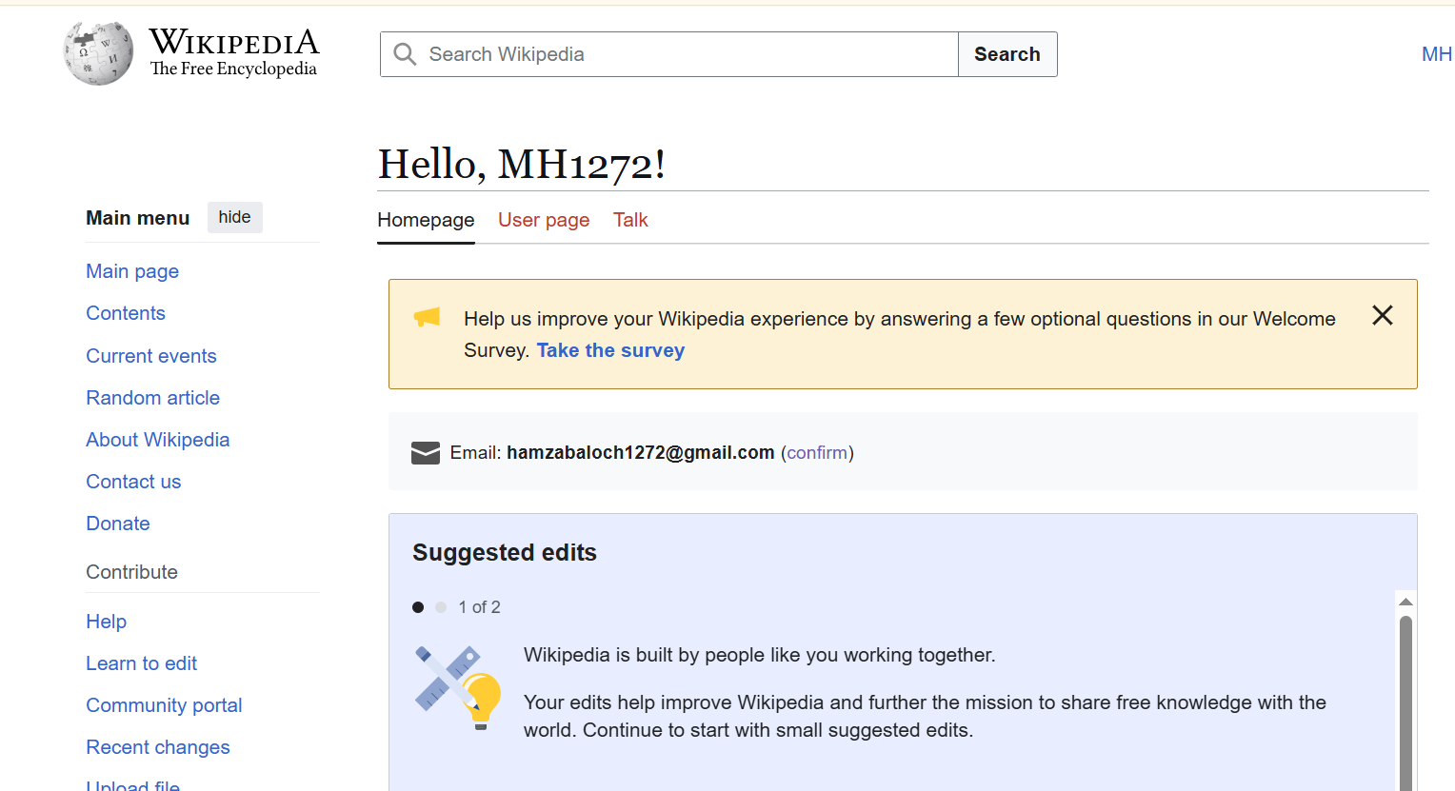**

|  |  |
| --- | --- |
| Test Case ID | TC_WIKI_18 |
| Test Case Title | Verify that the "Printable version" link works correctly on any Wikipedia article page |
| Pre-Conditions | Wikipedia article page is open |
| Test Steps | 1. Open any Wikipedia article page  2. Locate the "Printable version" link in the sidebar (usually       under Tools section)  3. Click on the "Printable version" link  4. Observe whether a new page or view opens with       simplified, printer-friendly layout |
| Test Data | Browser: Chrome / Firefox  Article page: "Software testing" (or any Wikipedia article) |
| Expected Result | A printer-friendly version of the article is displayed with minimal |
| Actual Result | Printable version page opens correctly, showing main content without sidebars, as expected |
| Status | Pass |
| Remarks | Verified for multiple articles; printer-friendly layout works correctly; no issues observed |

**Screenshot:**

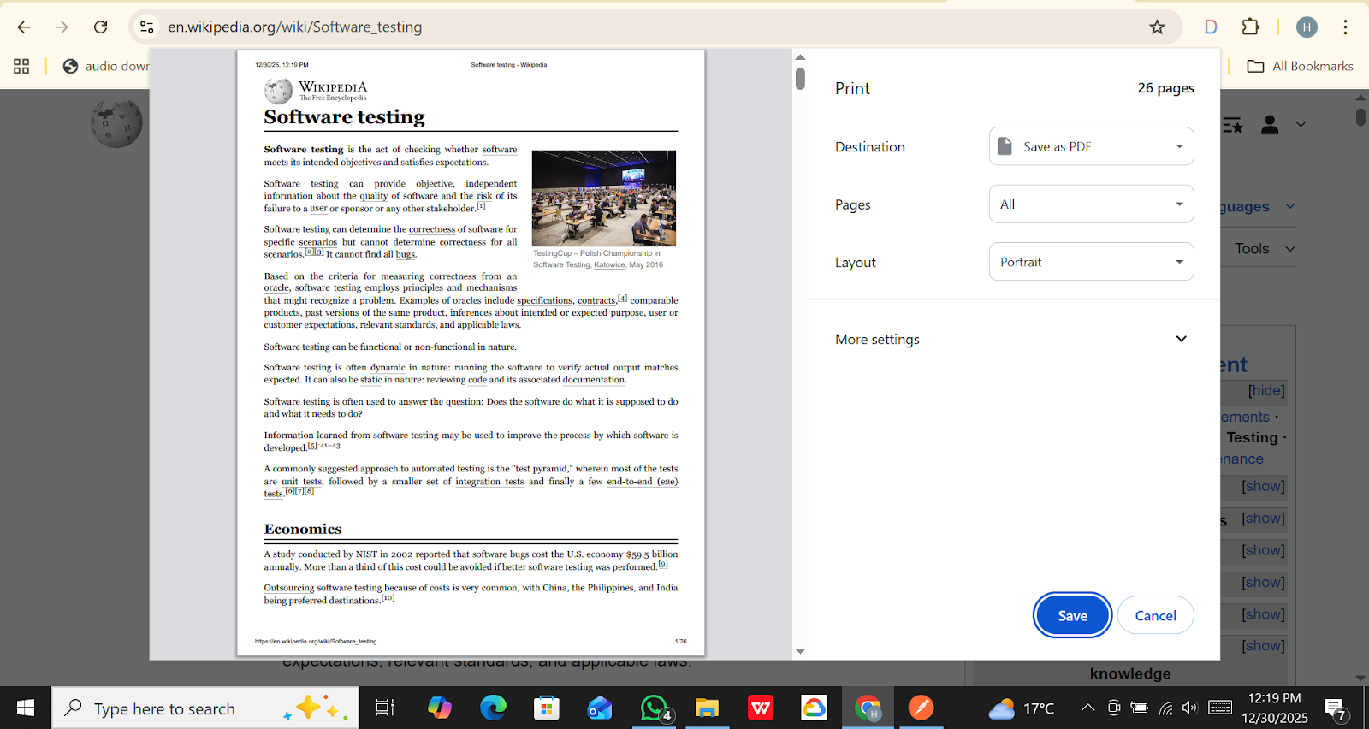

|  |  |
| --- | --- |
| Test Case ID | TC_WIKI_19 |
| Test Case Title | Verify session handling when using Back button after logout |
| Pre-Conditions | Wikipedia account exists  User is logged in |
| Test Steps | 1. Open Wikipedia and login with valid credentials  2. Navigate to any article page or user-specific page  3. Logout from the account  4. Press the browser's 'Back' button  5. Observe whether the previous page reloads and if user content is protected / session is expired |
| Test Data | Browser: Chrome / Firefox  Username / Password: Valid Wikipedia credentials |
| Expected Result | After logout, pressing the Back button should not show any private user content. Wikipedia should either redirect to login page or show session expired message |
| Actual Result | After logout, pressing Back button still shows the previously visited article page (read-only), but account-specific actions like editing or watchlist are inaccessible |
| Status | Pass (or Negative scenario: minor session exposure – read-only content visible) |
| Remarks | Session properly prevents account actions after logout. Read-only content visible due to browser cache; no sensitive account data is exposed |

**Screenshot:**

**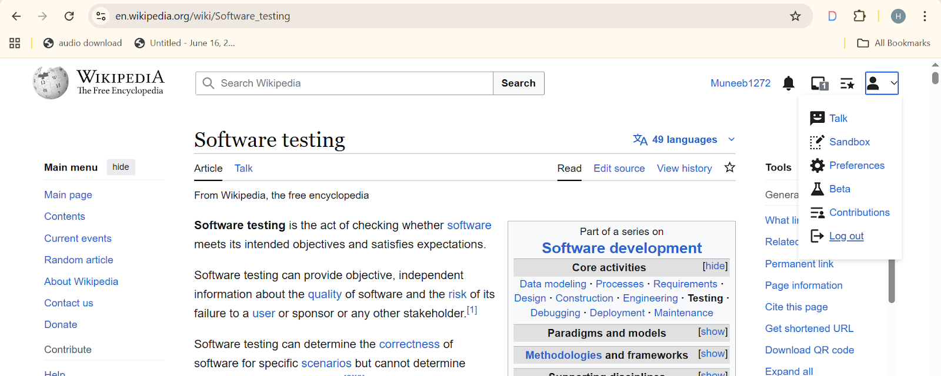      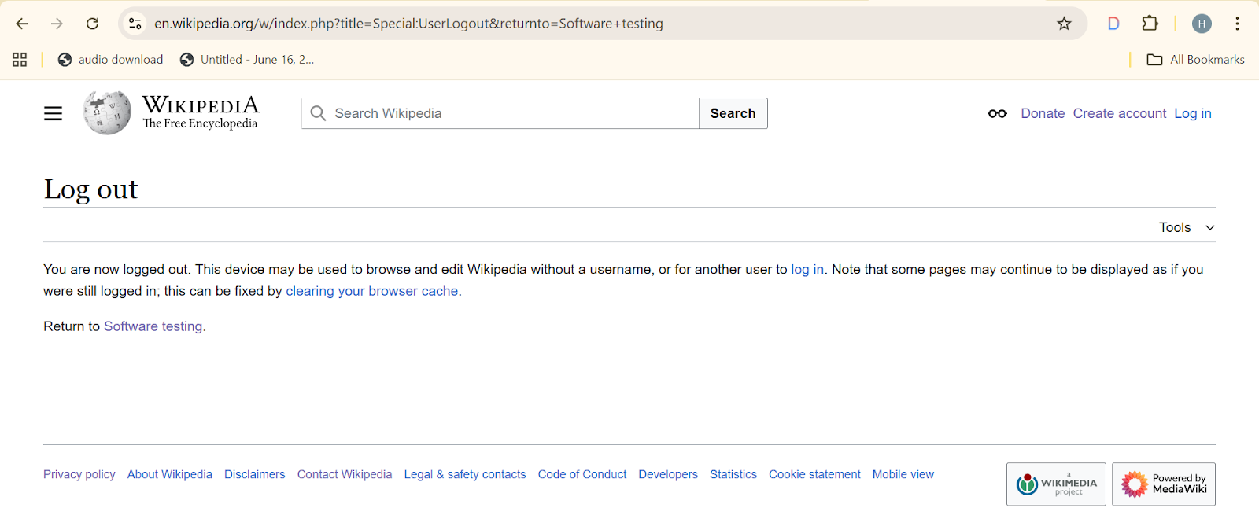**

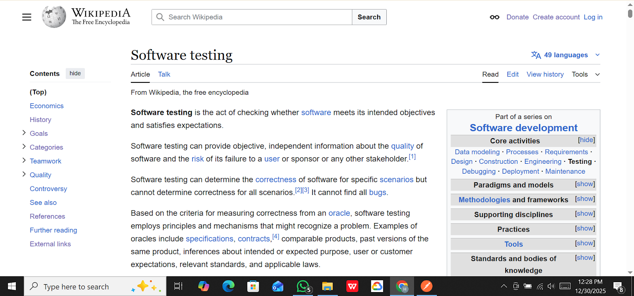

|  |  |
| --- | --- |
| Test Case ID | TC_WIKI_20 |
| Test Case Title | Verify that clicking the Talk tab opens the article’s discussion page |
| Pre-Conditions | - Wikipedia homepage is loaded  - Any article page accessible |
| Test Steps | - Wikipedia homepage is loaded  - Internet connection active  - Browser open  - Any article page accessible |
| Test Data | Browser: Chrome / Firefox  Article: Any Wikipedia article (e.g., "Software testing") |
| Expected Result | Clicking the "Talk" tab should navigate to the corresponding discussion page for the article, showing discussion threads and talk page content |
| Actual Result | Talk page opens successfully; discussion threads are visible; no article editing content is shown here |
| Status | Pass |
| Remarks | Talk page navigation verified. All discussion threads load correctly. User can read and participate if logged in. |

**Screenshot:**

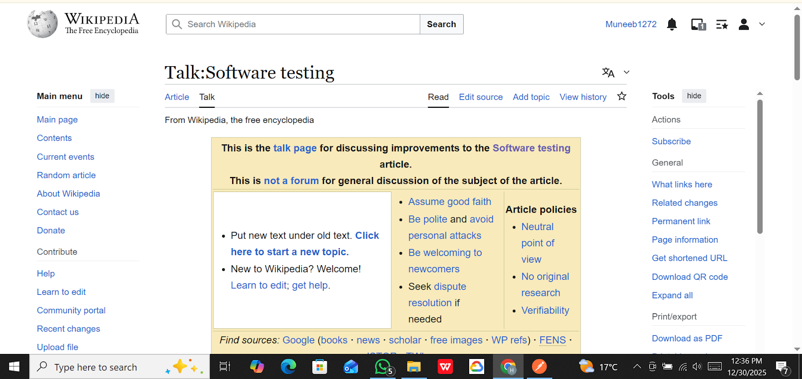

⋆˙⟡ T H A N K Y O U ⟡˙⋆